Huntsville Remote Fire Truck Quick Start Guide

**Table of Contents**

**How to Turn the Fire Truck On/Off 3**

**How to Turn the Controller On/Off 6**

**Controller Commands 7**

**How to Fill the Water Reservoir 8**

**How to Charge All of the Batteries 9**

1. Charging the Arduino Battery 9

2. Charging the Motor Battery 10

3. Charging the Servo Battery 11

4. Charging the Controller 13

**Quick Start Troubleshooting 14**

Issue 1: Fire Truck will not move 14

Issue 2: The Fire Truck is not steering 16

Issue 3: Fire Truck is not shooting water when prompted to 17

**Quick Start Guide**

# How to Turn the Fire Truck On/Off

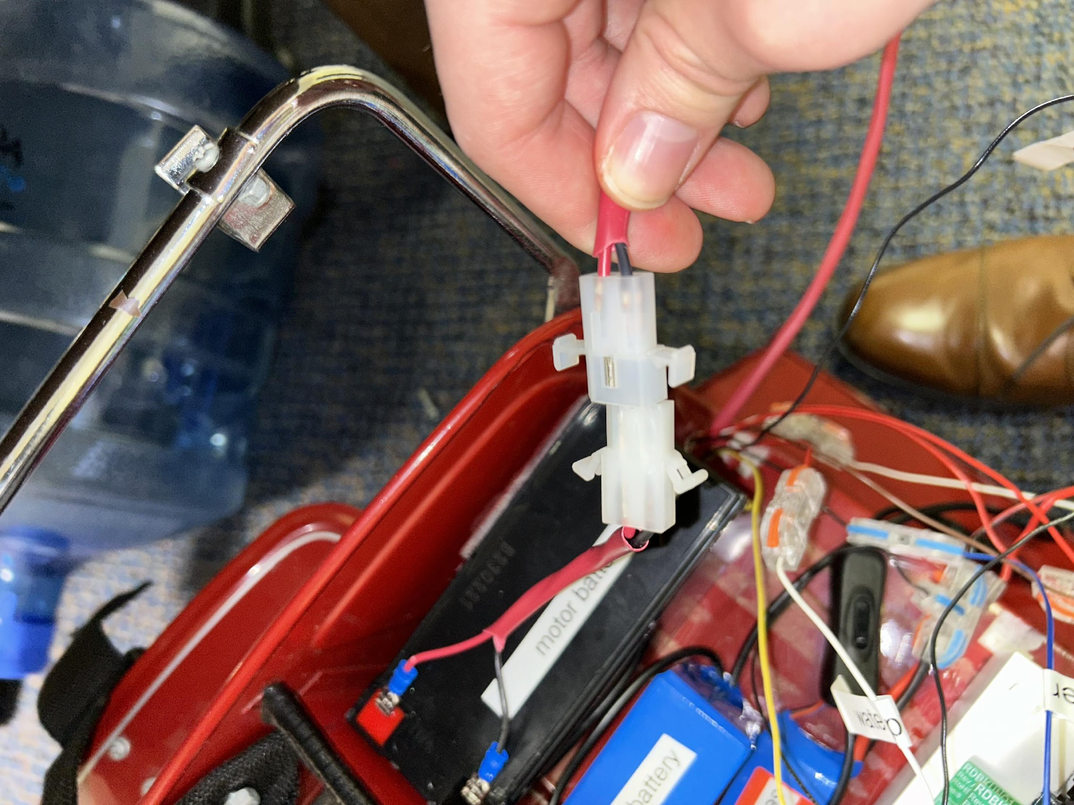

***Figure 1***

**Steps**:

1. Navigate to the back of the fire truck where the 'trunk' is located

2. Lower the tailgate on the back of the fire truck

3. Upon lowering the tailgate, look for two clips that look like the ones in “Figure 1”. One clip will be connected to the battery labeled 'motor battery' and the other clip will have a thick red cover on it. Once you find the clips, pictured above, click them together

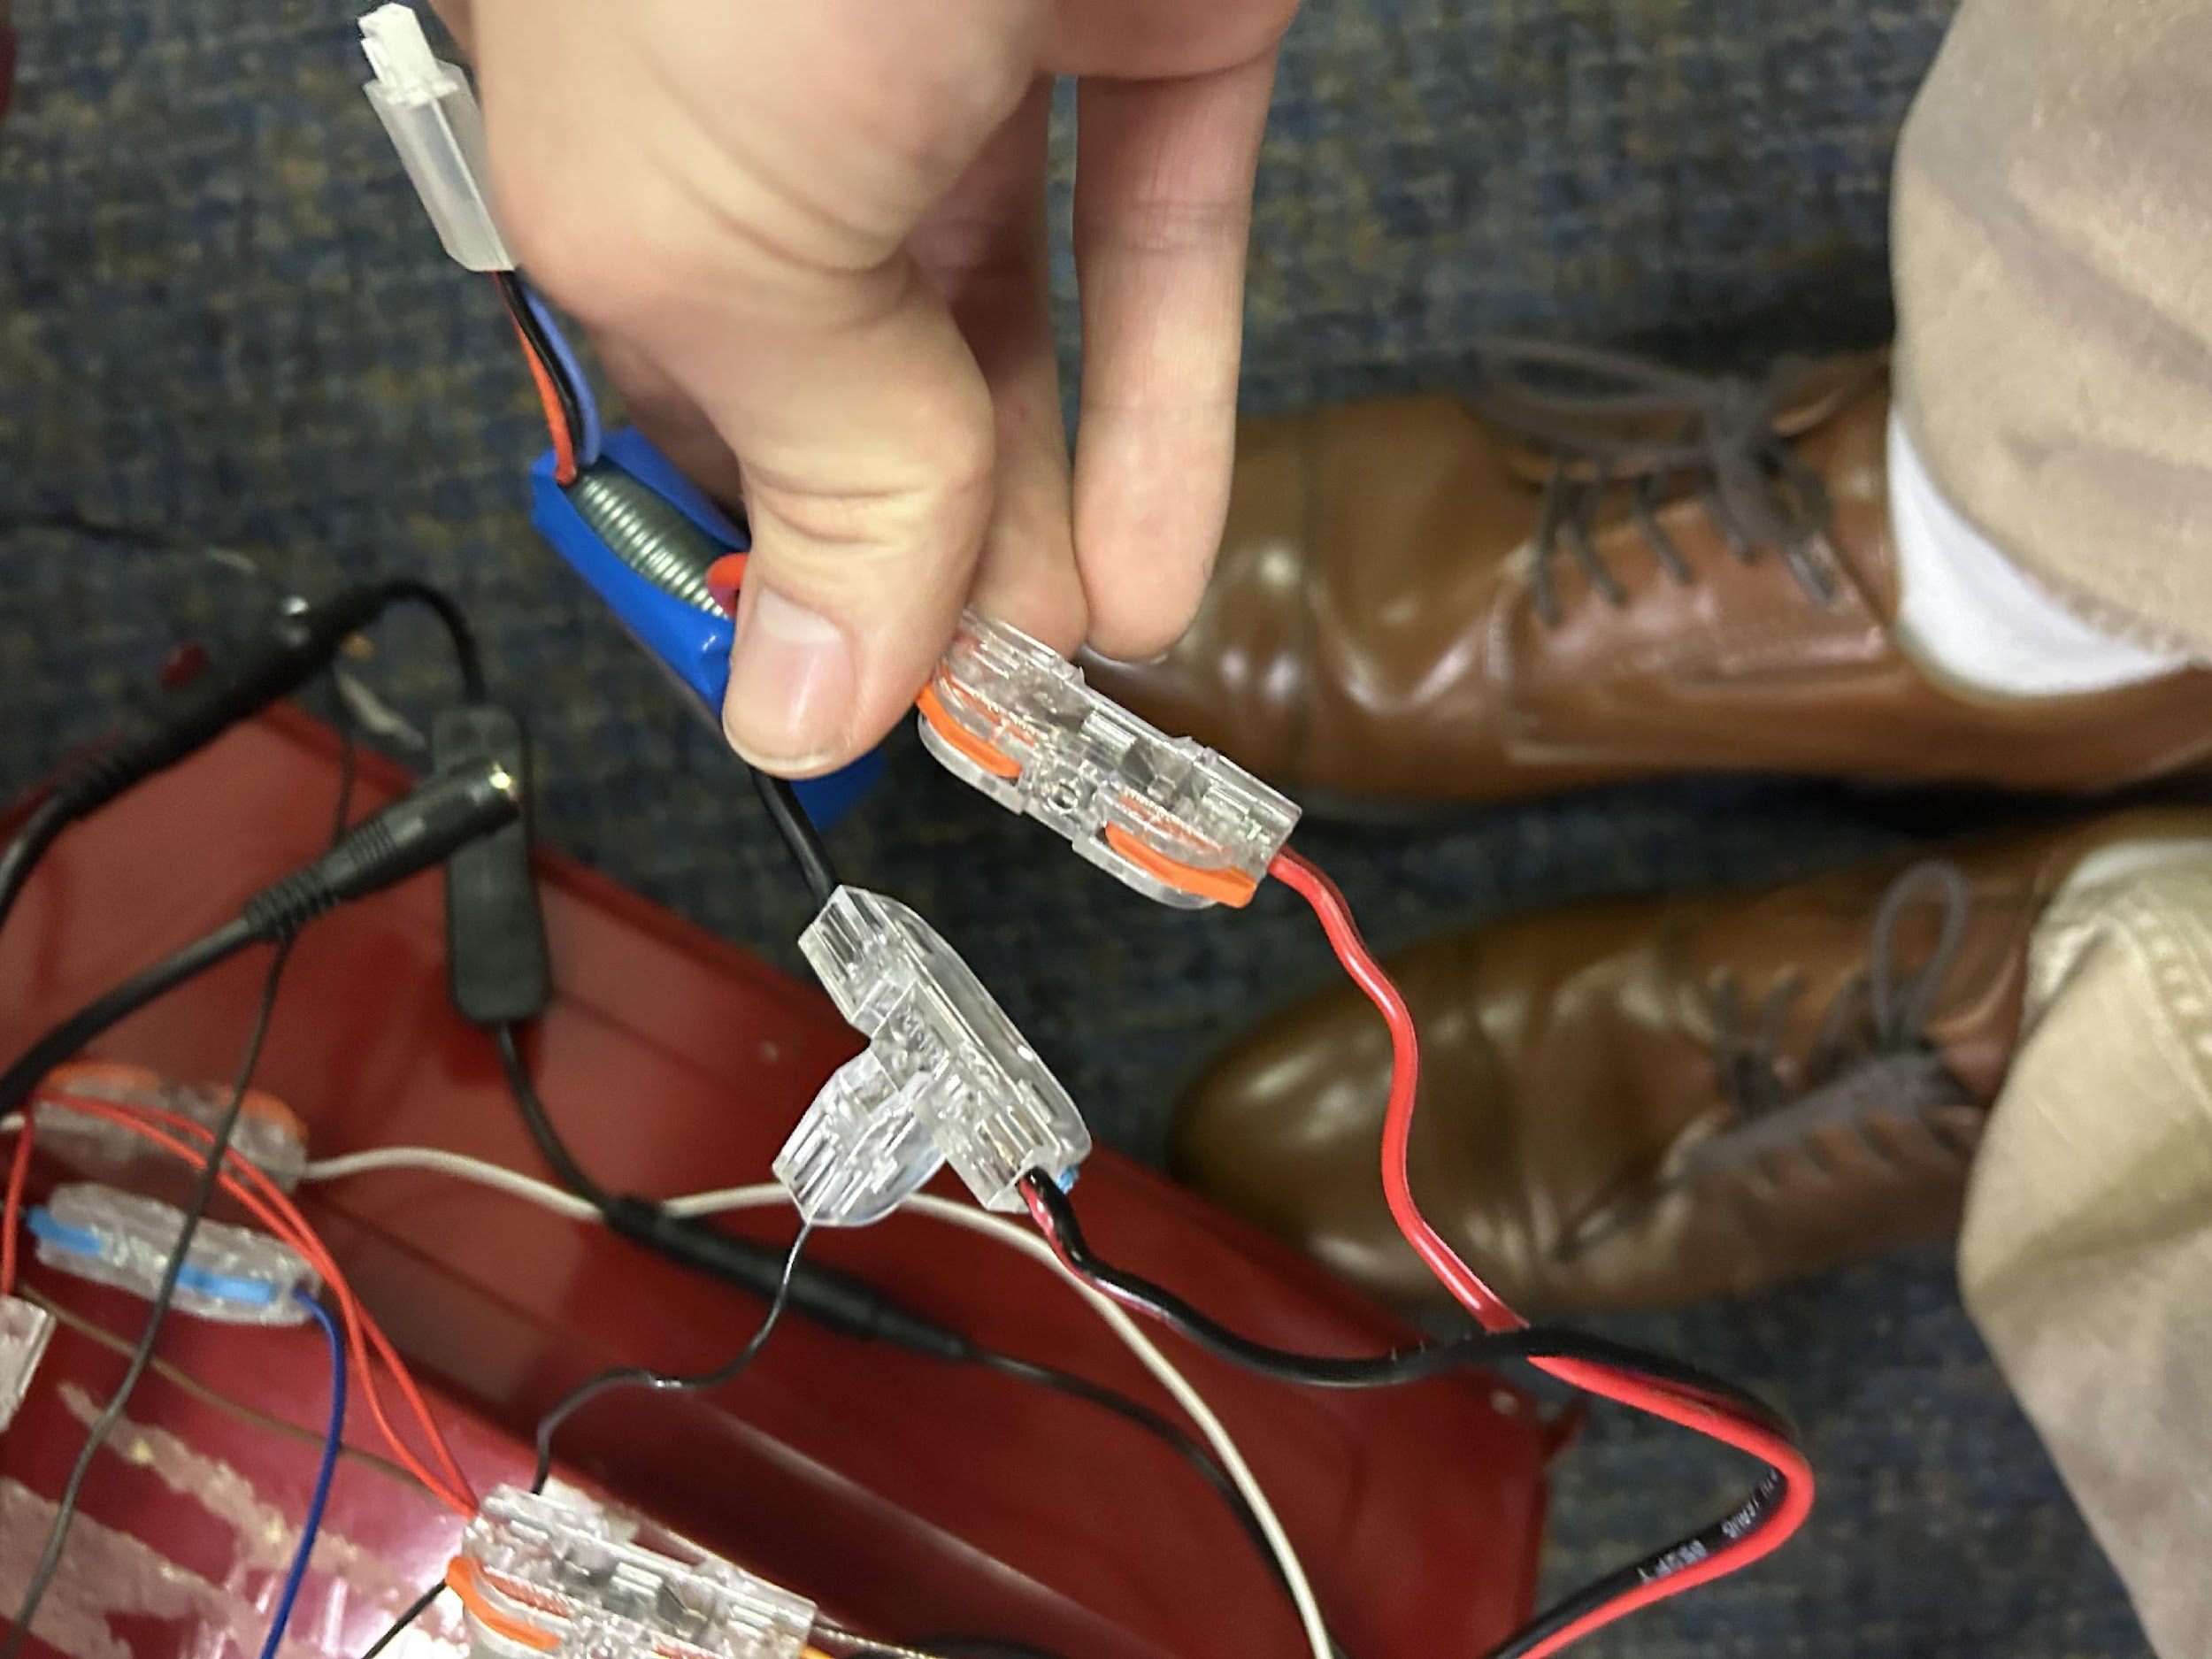

***Figure 2***

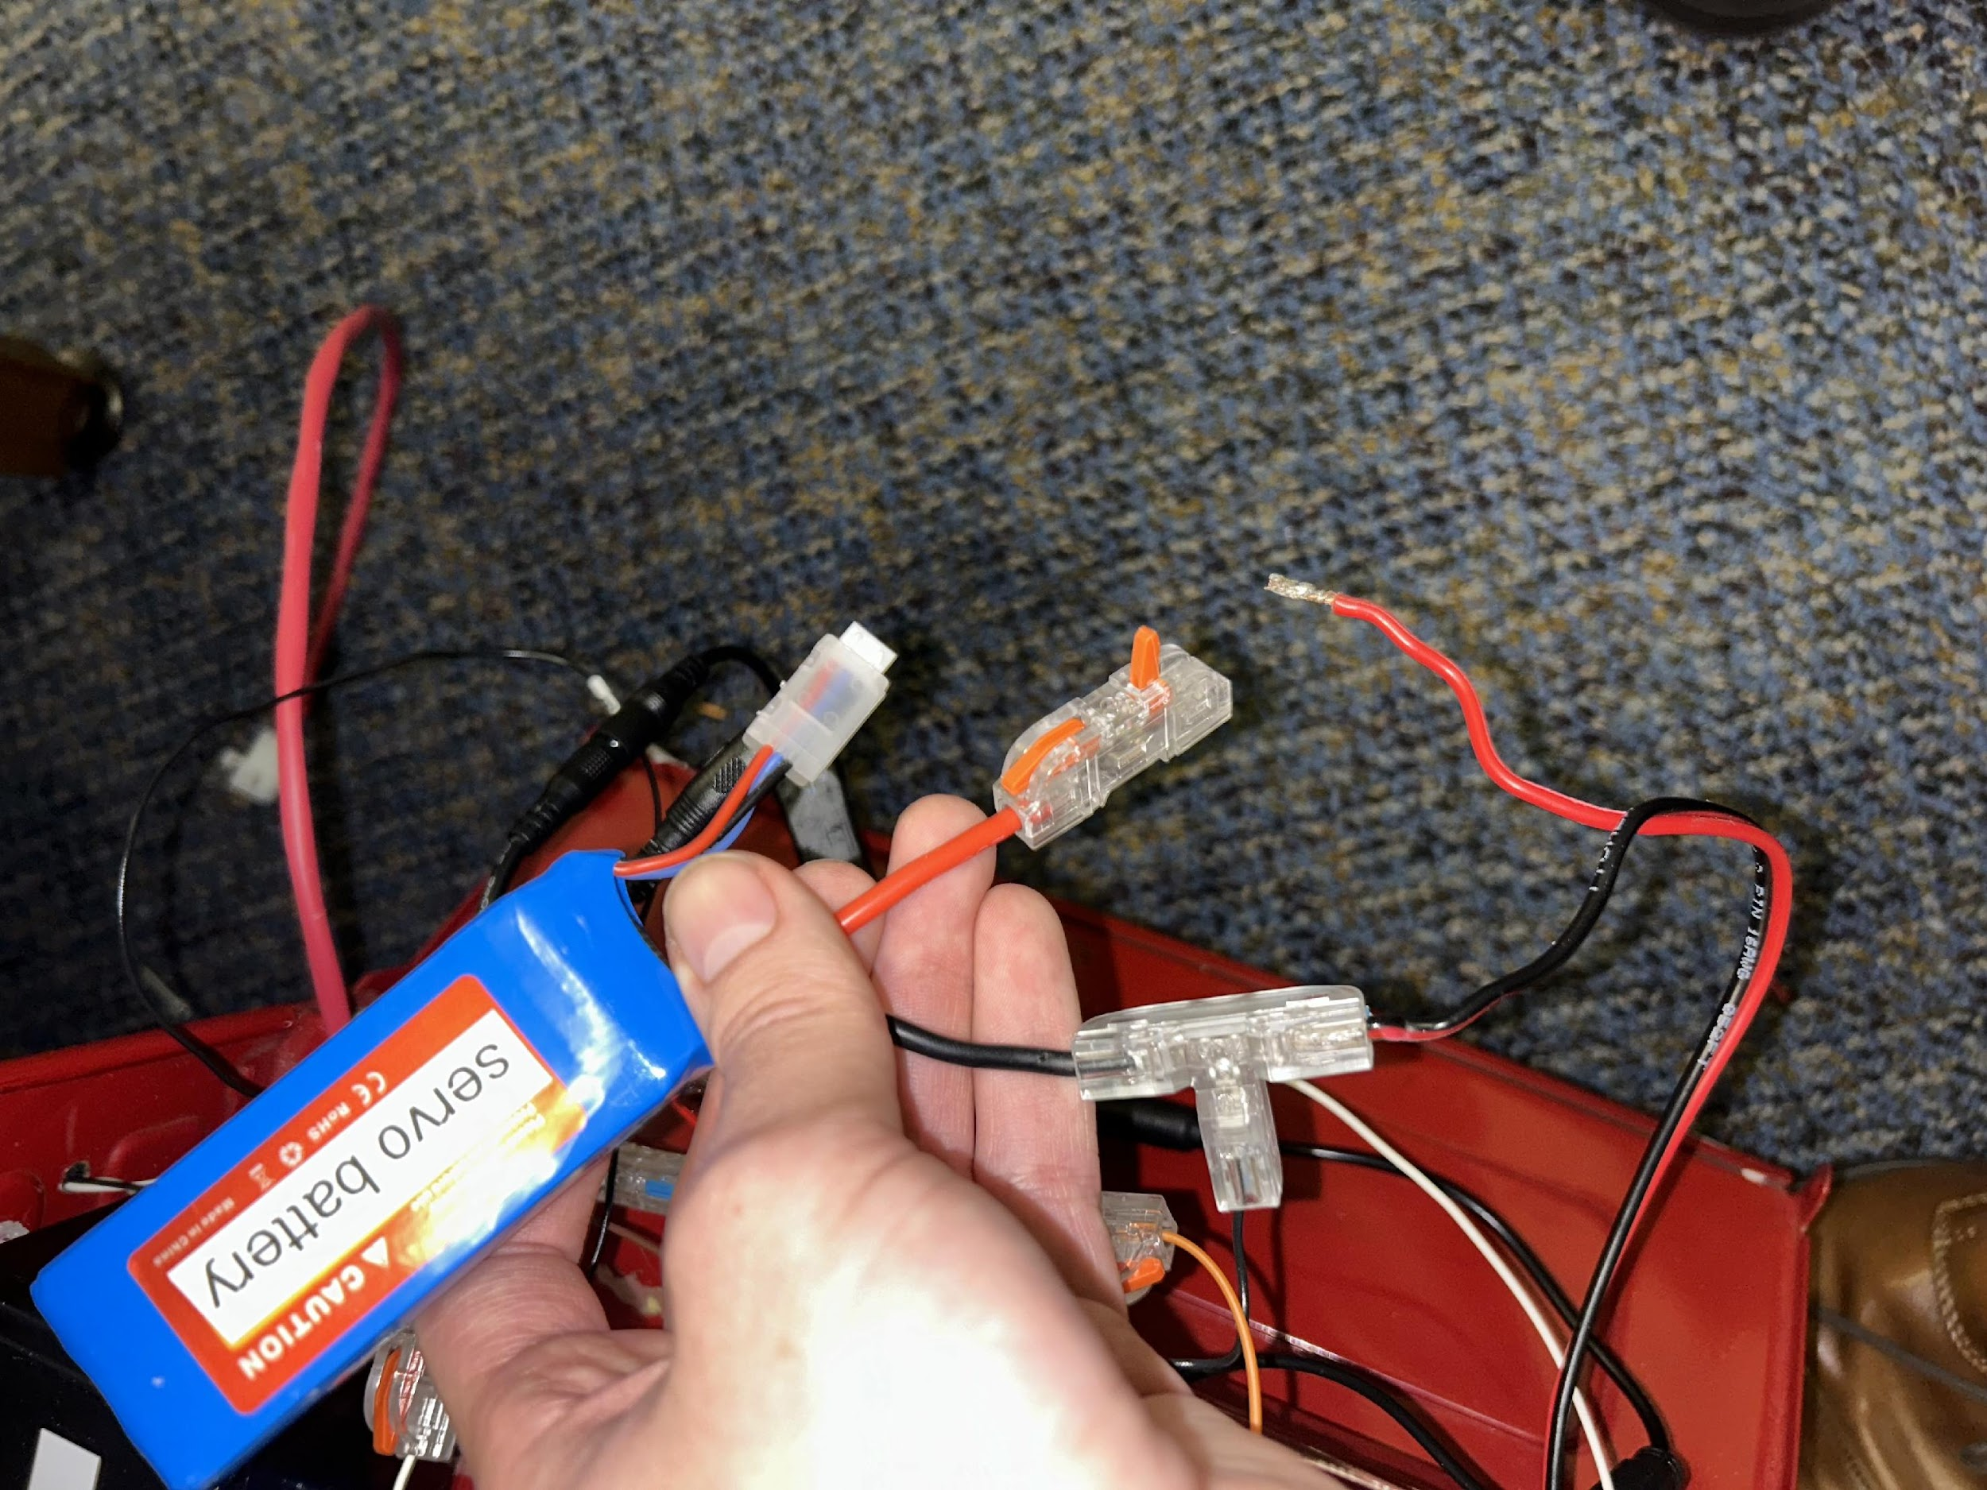

***Figure 3***

4. After you clip the motor battery together with the motors, look for the battery labeled 'servo battery'

5. Once you find it, look for a loose red wire that looks like the one in the above photo and grab it

6. Once you have the red wire, connect it to the plastic connector like in “Figure 2”. You will want to lower the red tab of the plastic connector onto the red wire to ensure a tight secure connection. “Figure 3” shows both ends that need to be connected

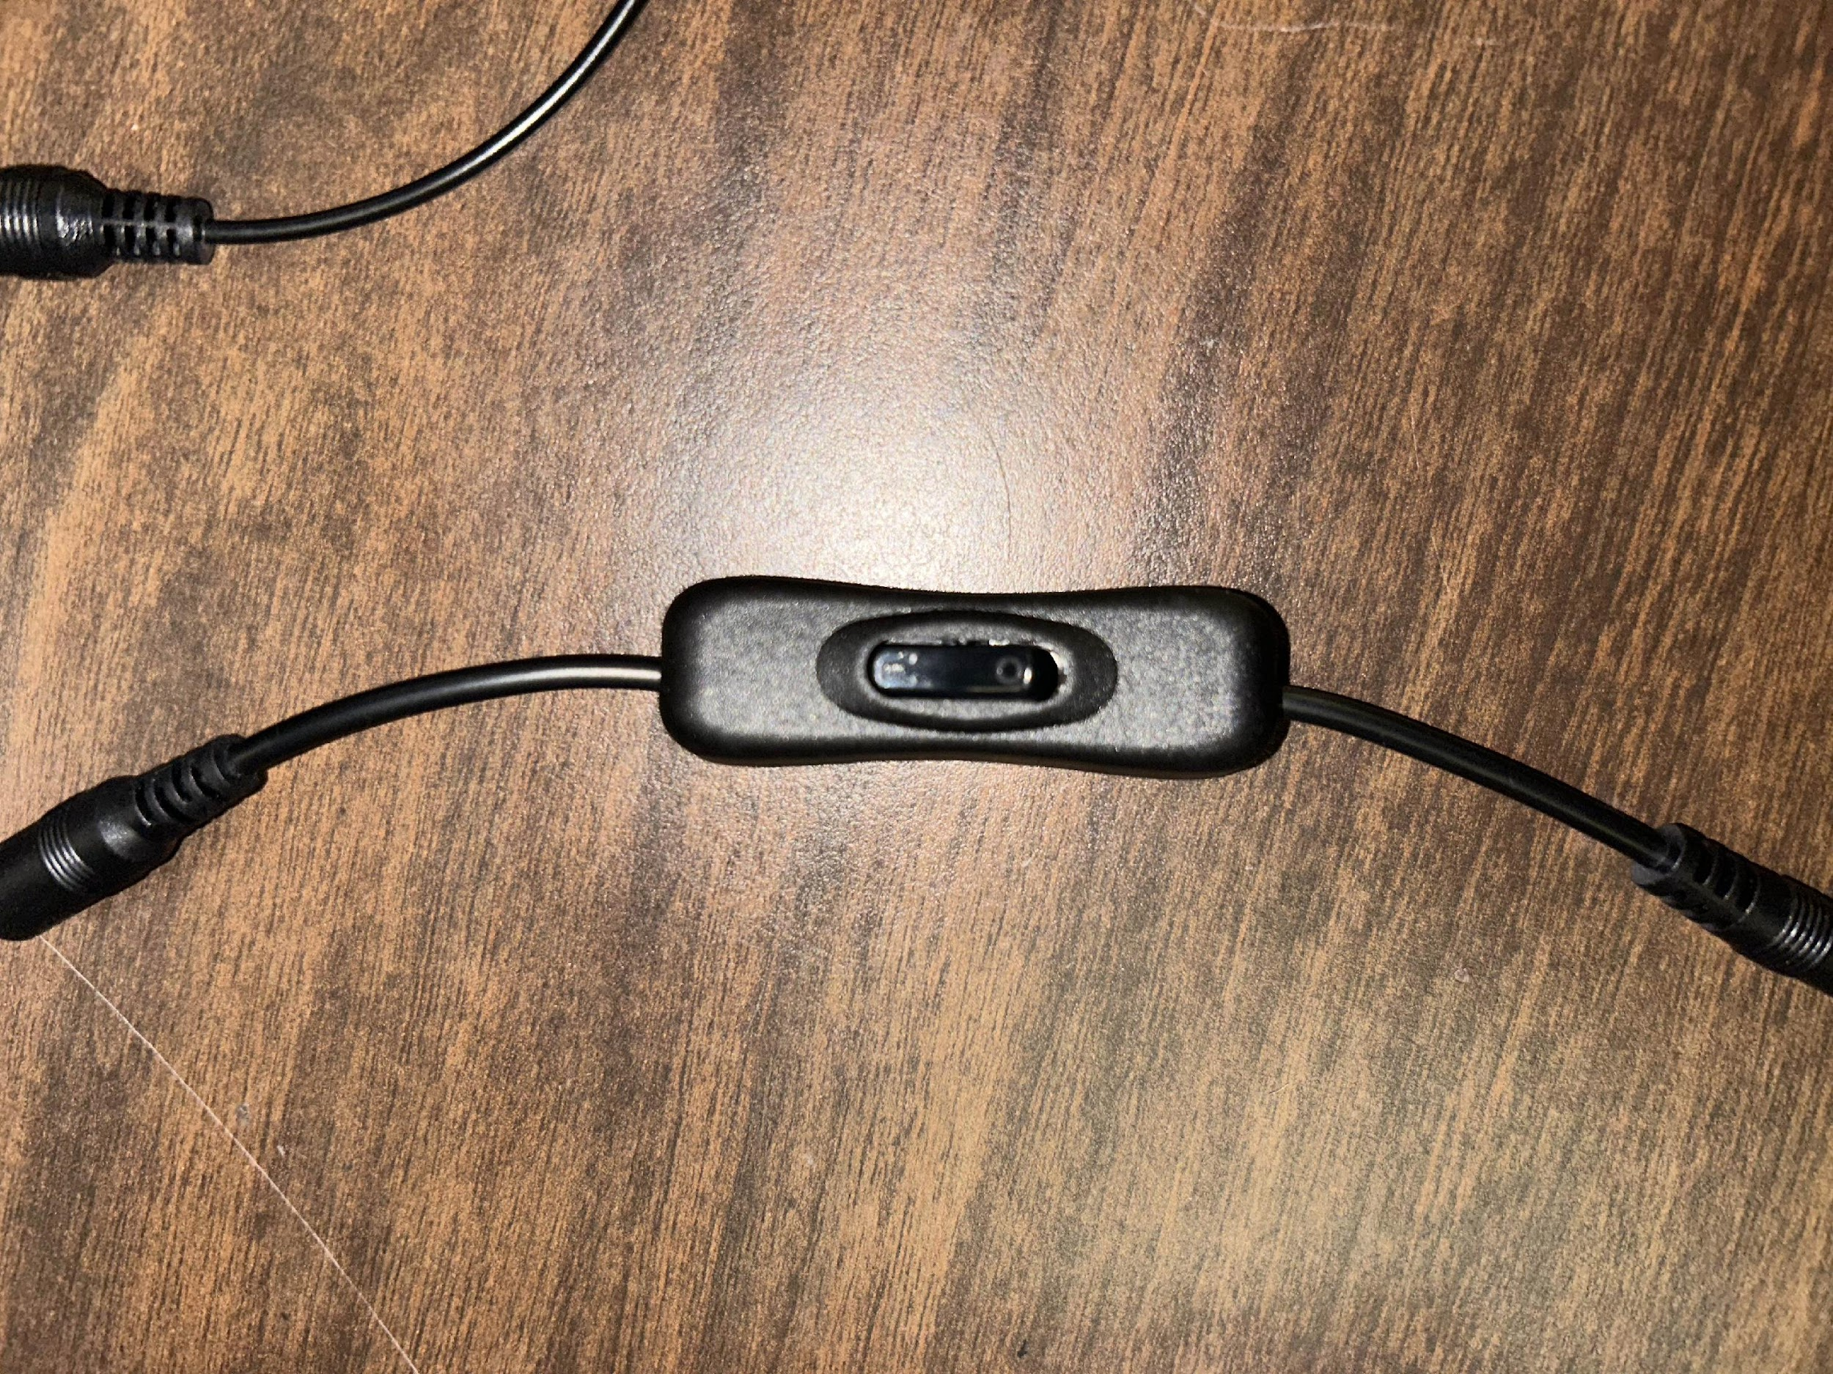

***Figure 4***

7. After you click the clips together, look for a switch like in “Figure 4”, also in the trunk, and flick it on. You will know if it is on or not if there is any light coming from the capsule with the boards inside

**NOTE:** to turn the fire truck OFF, follow the same steps that are declared above, but in **REVERSE ORDER**

# How to Turn the Controller On/Off



***Figure 5***

**Steps**:

1. First make sure that the fire truck has been turned on, as done in the previous section

2. Once you have the fire truck turned on, you are going to get your controller and turn it on by holding both the share and the PlayStation button, as visualized in “Figure 5”

3. You are going to hold these two buttons until the controller flashes its lights and turns into a solid blue. If your controller light is a solid, stable blue, then you have paired the controller successfully and are ready to operate it. There is also no need to manually turn off the controller, once you power down the fire truck then the controller automatically turns off a couple of seconds after powering everything off.

# Controller Commands



***Figure 6***

Please refer to “Figure 5” for details regarding how to control the fire truck. Note that the water pump is activated through a toggle control, so you must click the square button once to turn it on and once to also turn it off. Lastly, for those who don't know, the button 'R3' is the button that resides within the right stick, so when you press down on the right stick, it is supposed to reset the direction of the fire truck, thus turning the wheels straight ahead.

# How to Fill the Water Reservoir

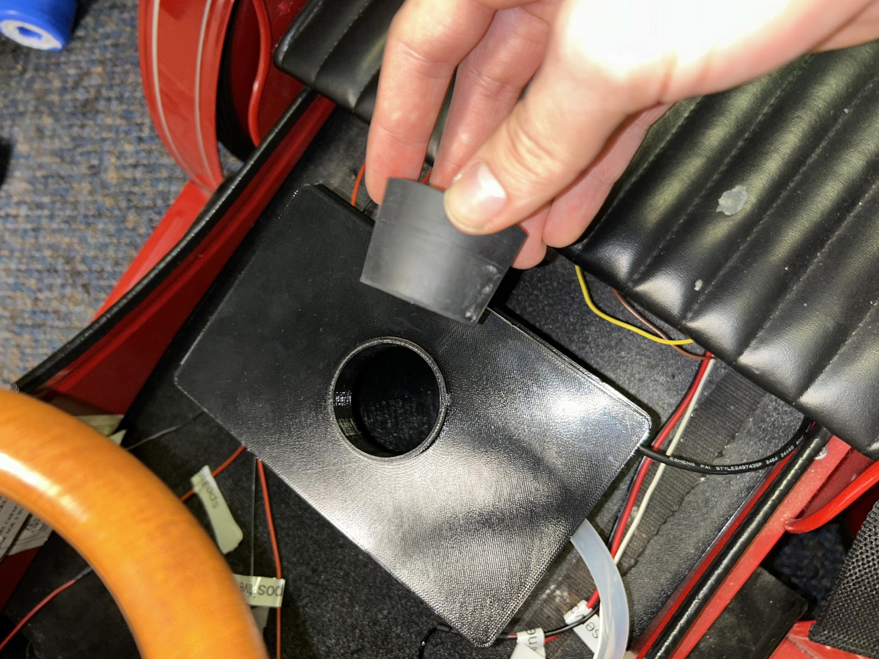

***Figure 7***

When you first receive this fire truck, there is likely not going to be any water inside the reservoir.

**Steps:**

1. In the middle of the fire truck, locate a black container, the reservoir, such as “Figure 6”. This container will be below the steering wheel of the fire truck

2. On the top of the reservoir, there will be a plug like the one being held in the picture above. Remove the plug from the reservoir

3. Lastly, fill the reservoir with water and insert the plug back on

**NOTE:** it is better to fill the reservoir while it is still on the fire truck, but if you want to take the reservoir off to fill, please remember which wire goes where when you hook everything back up

# How to Charge All of the Batteries

**NOTE: THE ARDUINO MUST BE POWERED OFF BEFORE CHARGING ANY BATTERIES (USING THE SWITCH FROM THE PREVIOUS SECTION)**

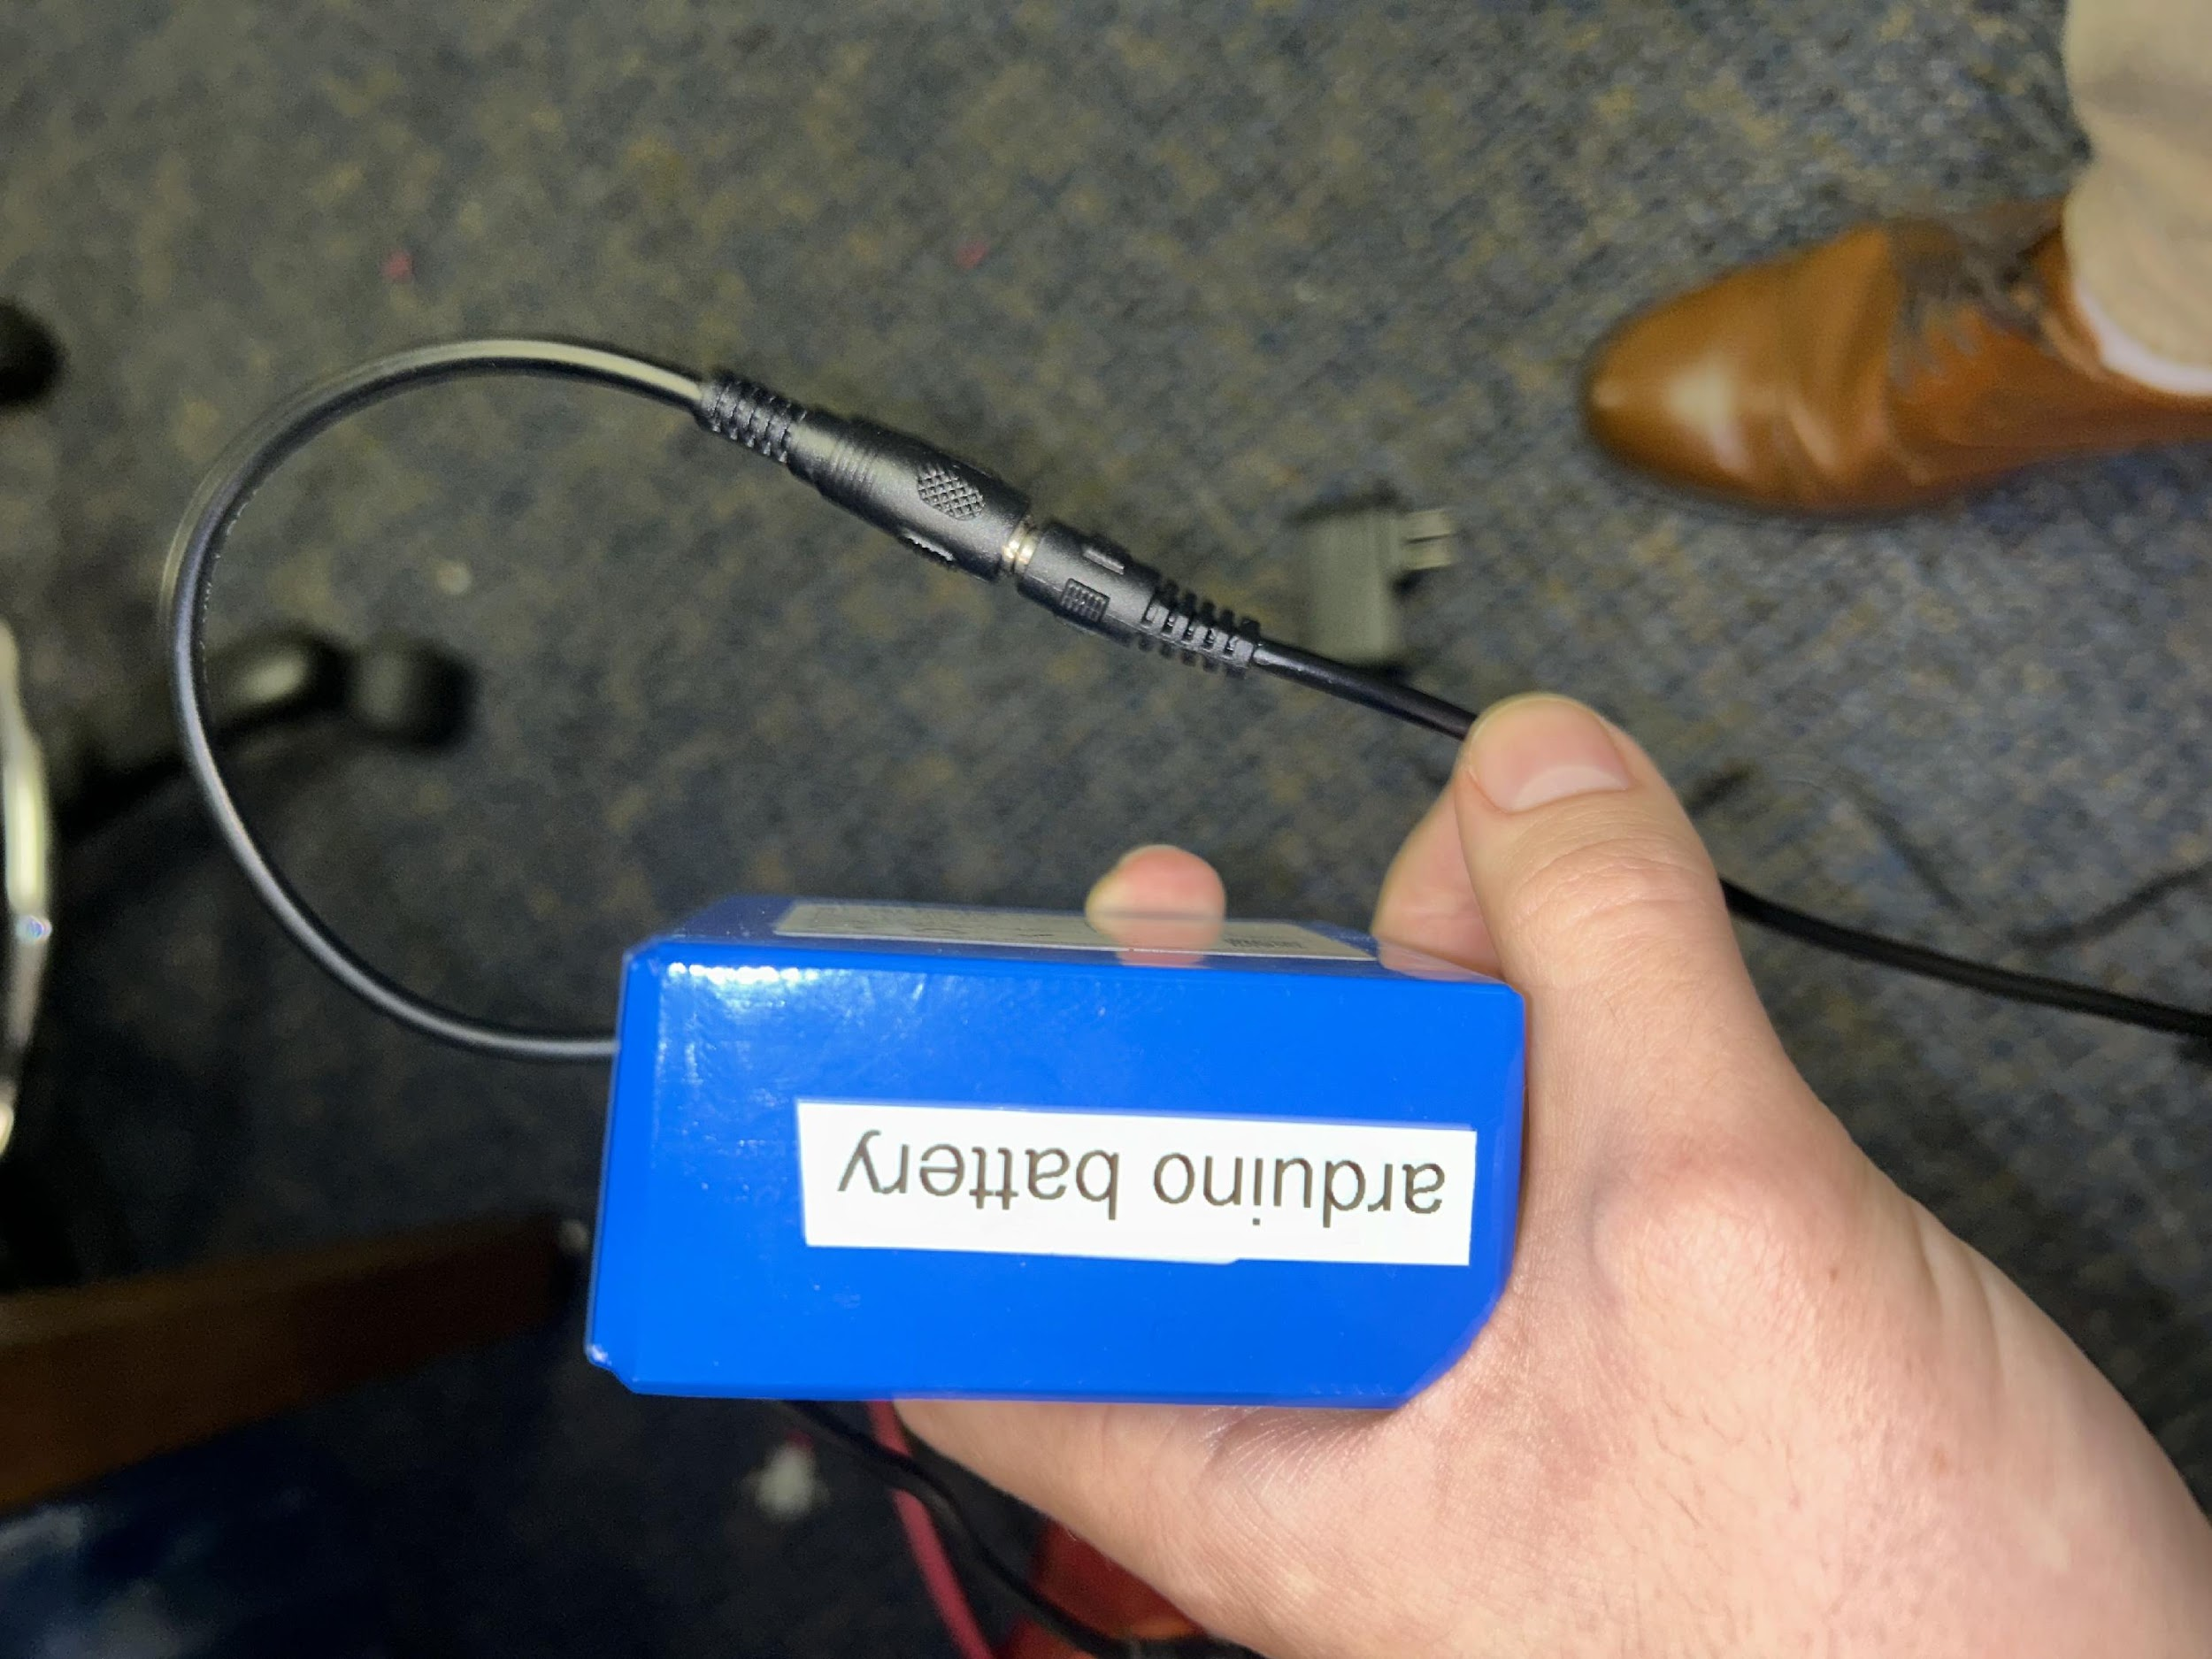

***Figure 8***

## 1. Charging the Arduino Battery

**Steps:**

1. To begin, navigate to the 'trunk' of the fire truck and take off the top cover

2. Locate the battery labeled 'arduino battery'

3. Take the charger labeled 'arduino charger' and plug it up into the barrel jack such as in “Figure 7”

4. Plug in the charger to the wall

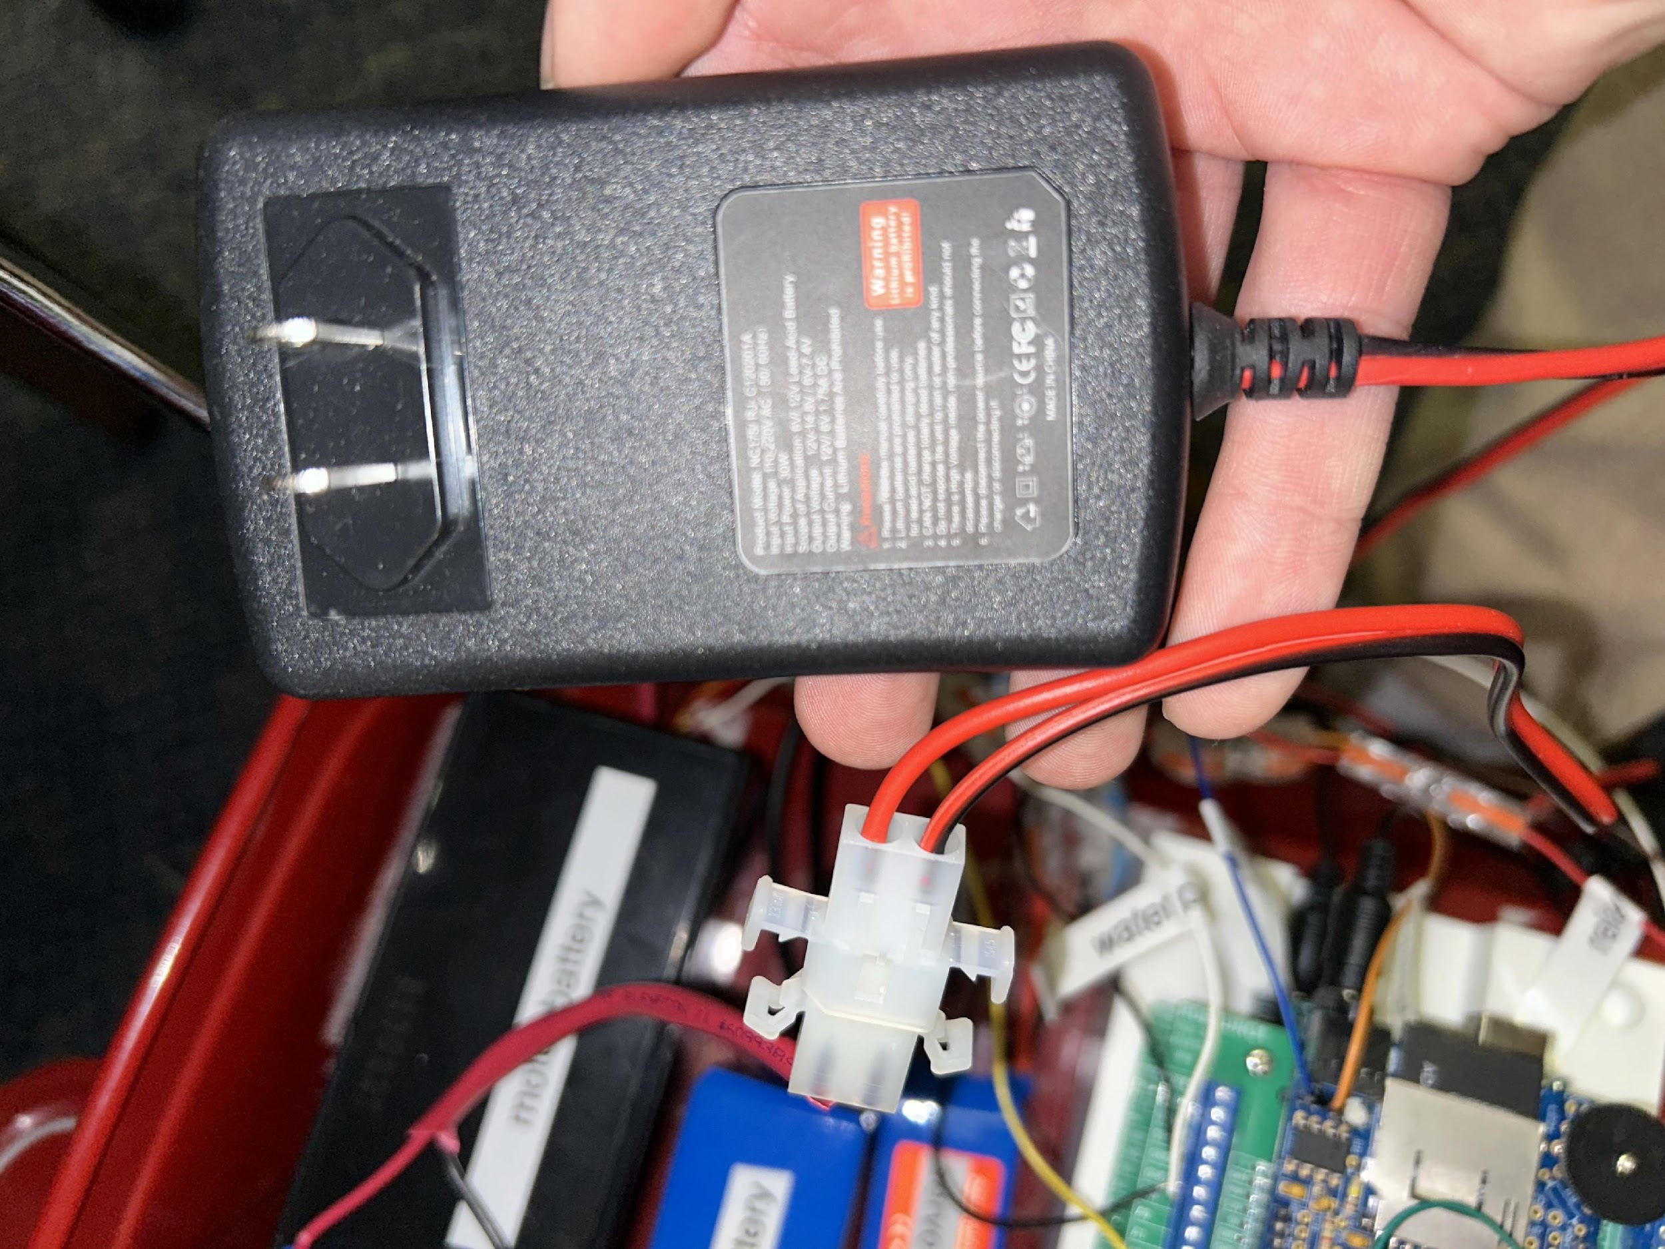

***Figure 9***

## 2. Charging the Motor Battery

**Steps:**

1. To begin, navigate to the 'trunk' of the fire truck and take off the top cover

2. Locate the battery labeled 'motor battery' in the trunk

3. Disconnect the battery from the thick red cable

4. Plug up your battery to the same port that you took the other cable out of

5. Plug in the charger to the wall

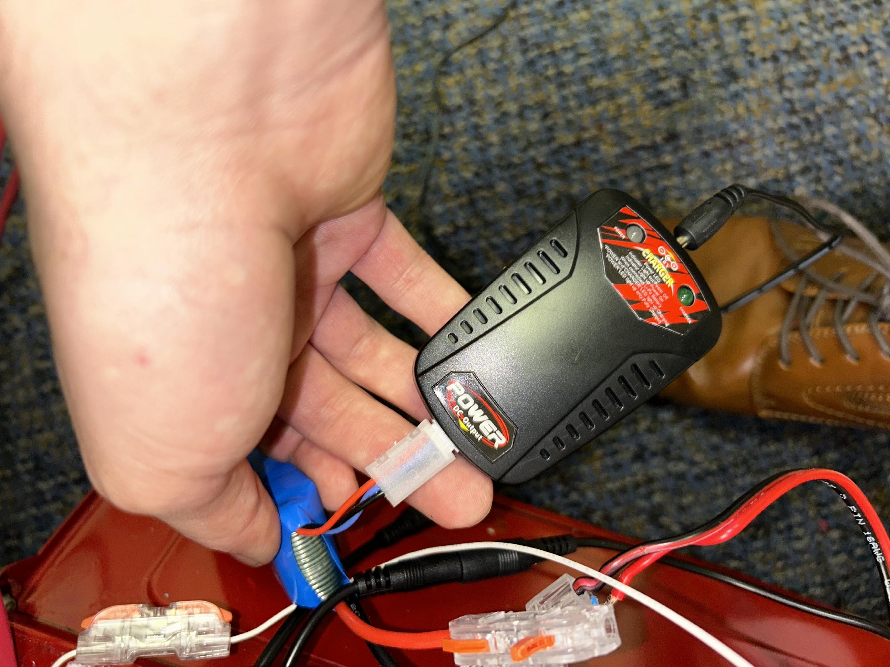

***Figure 10***

## 3. Charging the Servo Battery

**Steps:**

1. To begin, navigate to the 'trunk' of the fire truck and take off the top cover

2. Locate the battery labeled 'servo battery'



***Figure 11***

3. Before proceeding any further, please make sure that the red servo wire gets disconnected from the red wire of the battery by lifting up the little red tab of the plastic connector and taking the red wire out such as in the picture above

4. Once the red wire is unplugged, grab the charger that is used with the servo, as shown in the two pictures above, and plug up the battery

## 4. Charging the Controller

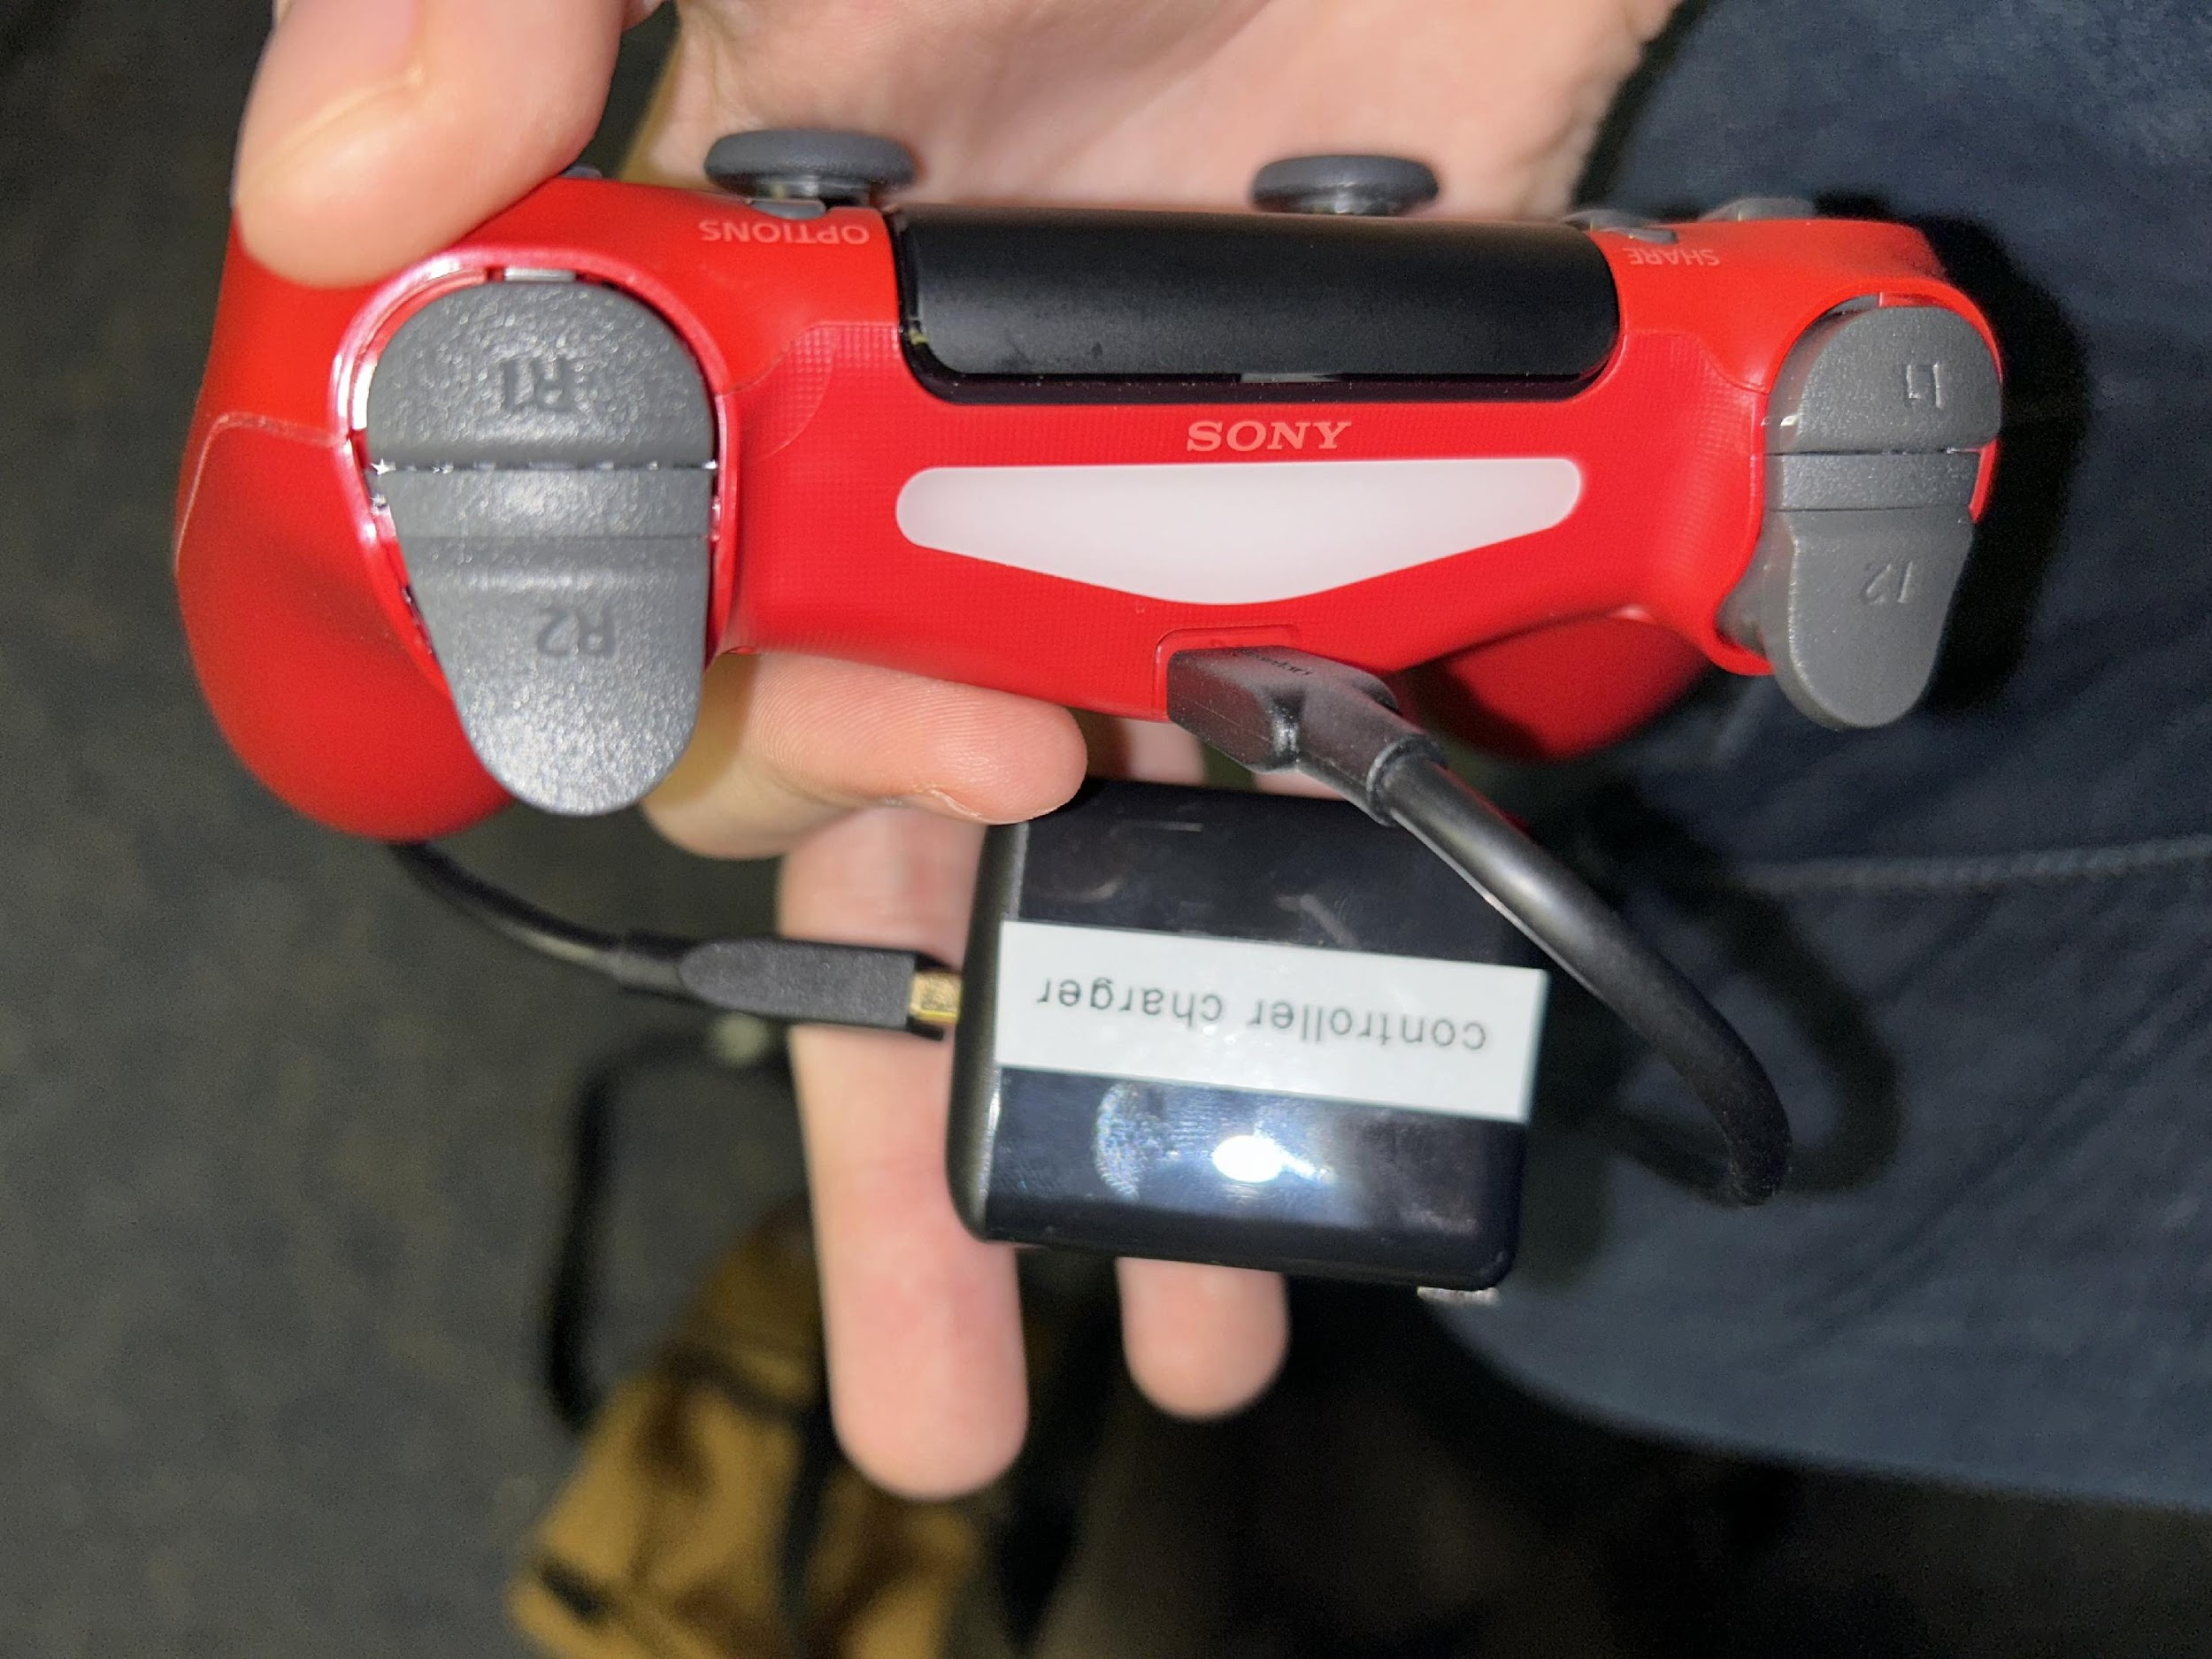

***Figure 12***

1. Locate the charger labeled 'controller charger' and plug it into the top of the controller (a simple micro USB cable would suffice as well)

2. Plug the charger into the wall

# Quick Start Troubleshooting

## Issue 1: Fire Truck will not move

If the fire truck is not moving then there are a couple of things that you will want to check

1. Is the Arduino turned on?



***Figure 13***

* If you do not see a green light inside of the Arduino capsule then it is likely not on. Please refer to 'How to Turn the Fire Truck On/Off' for more information

2. Is the motor plugged into the battery?

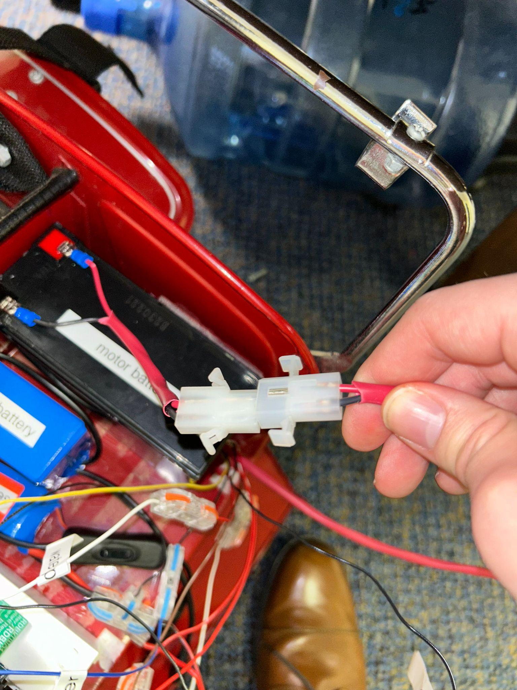

***Figure 14***

* If the motor is not plugged up like the above visual then you have not properly hooked up the motor battery. Please refer to 'How to Charge All of the Batteries' for more information

3. Is the controller turned on?

* If the controller is not lit up blue then the controller is not on. Please refer to 'How to Turn on the Controller On/Off' for more information

4. Is the motor battery charged?

* If the first three questions have been answered and the fire truck is still not moving, then the issue is likely that the battery for the motors is dead. Please refer to 'How to Charge All of the Batteries' for more information

## Issue 2: The Fire Truck is not steering

If the fire truck can move but you just cannot steer, the issue then is likely to be that something is going on with the servo

1. Is the servo hooked up properly?



***Figure 15***

* If the servo is not hooked up like the photo above, then that would be your issue. Please ensure that the thick red wire is hooked up properly like above. Please refer back to 'How to Turn the Fire Truck On/Off' for more information

2. Is the servo battery dead?

* If the issue is not the first one then likely the issue is that the servo battery is dead. Please refer to 'How to Charge All of the Batteries' for more information

## Issue 3: Fire Truck is not shooting water when prompted to

1. Is the reservoir out of water?

* If this is the issue, then please refer back to 'How to Fill the Water Reservoir' for more information on how to fix this issue

2. Is the controller turned on?

* If not, please refer back to 'How to Turn the Controller On/Off' for more information on how to fix this issue

3. Are you clicking the right button on the controller?

* Reminder, but the pink SQUARE button toggles on/off the water pump. For more information, please refer to the 'Controller Commands' section